PROGRESS PICTURES (28-08-2026)
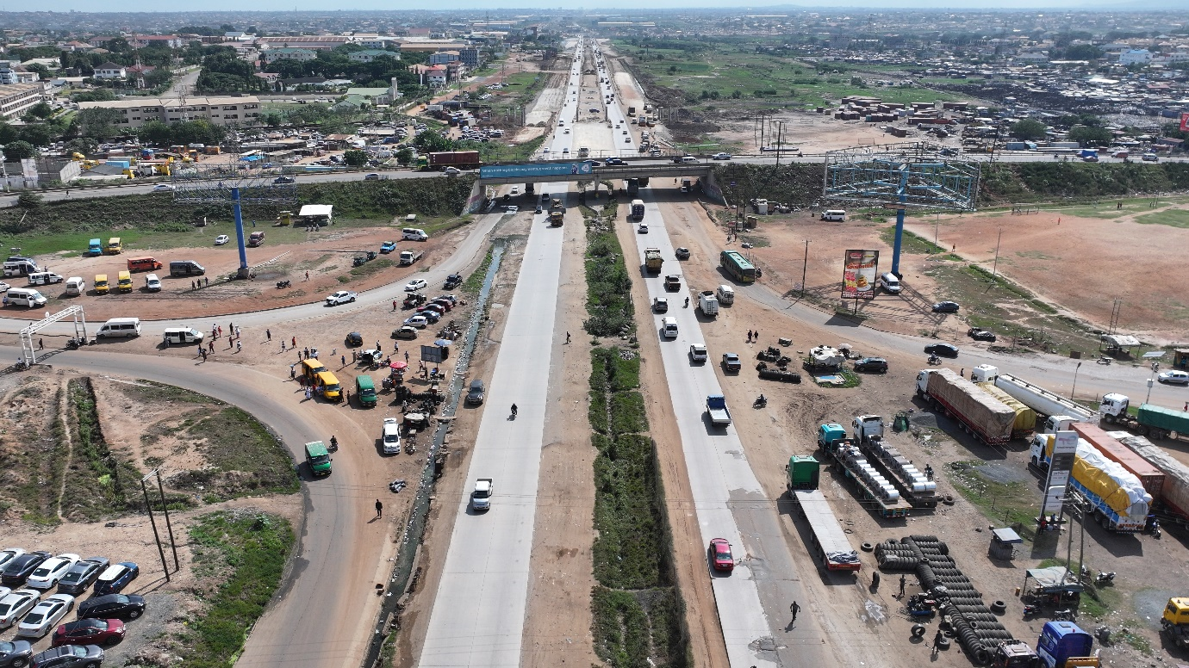
Figure 1 Ashaiman

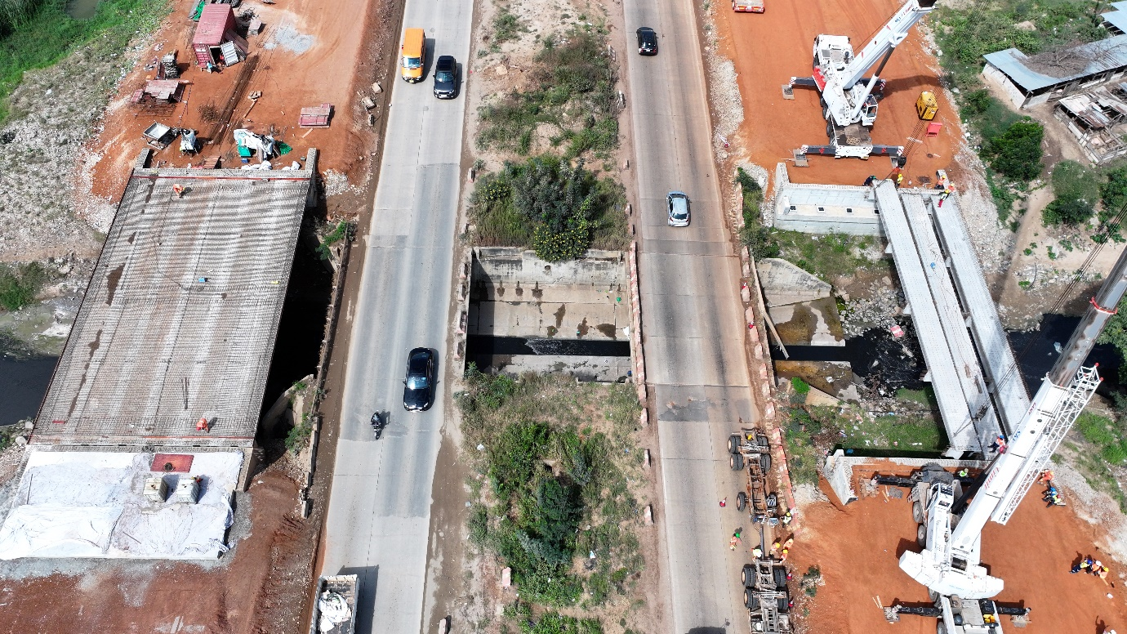
Figure 2 Bridge---Km 10+873.6 LHS & RHS (1)

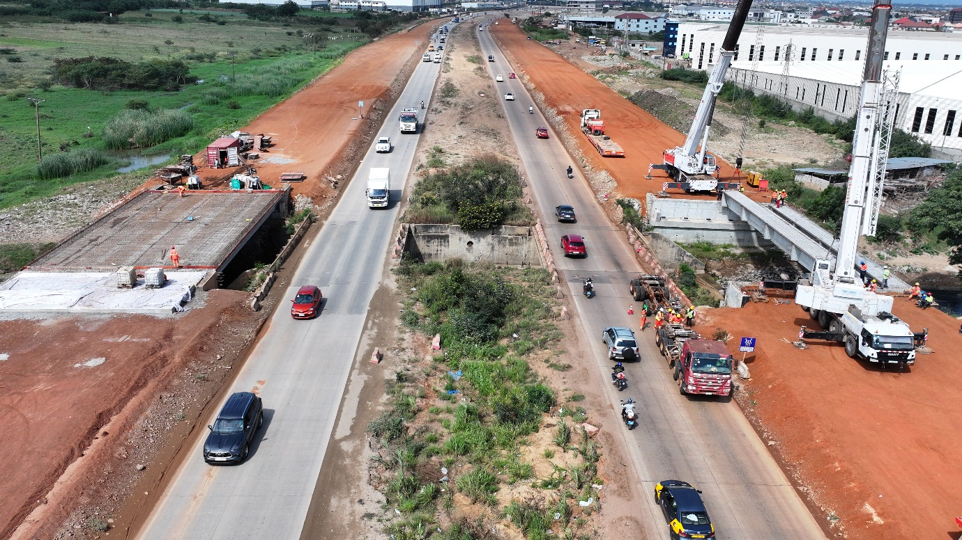
Figure 3 Bridge---Km 10+873.6 LHS & RHS (2)

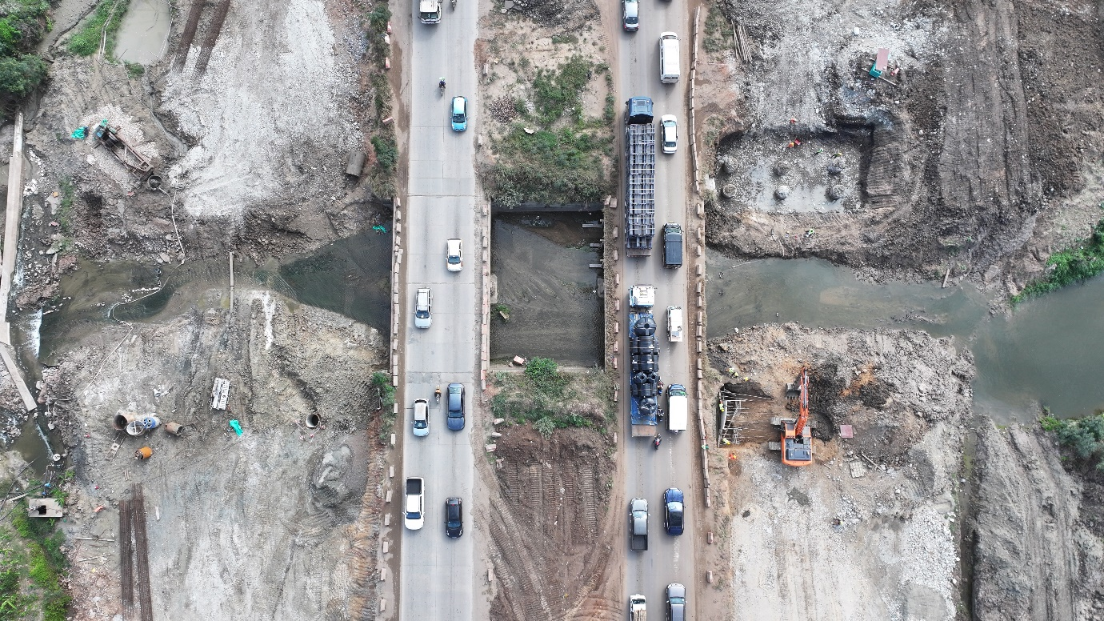
Figure 4 Bridge---Km 13+745.1 LHS & RHS (1)

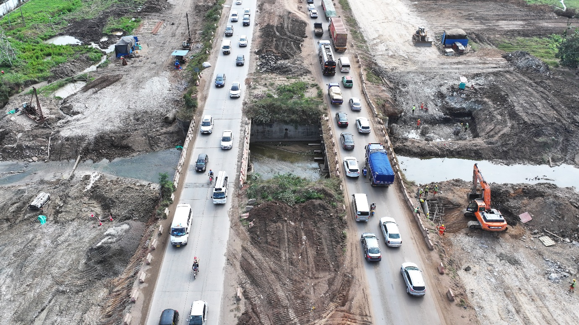
Figure 5 Bridge---Km 13+745.1 LHS & RHS (2)

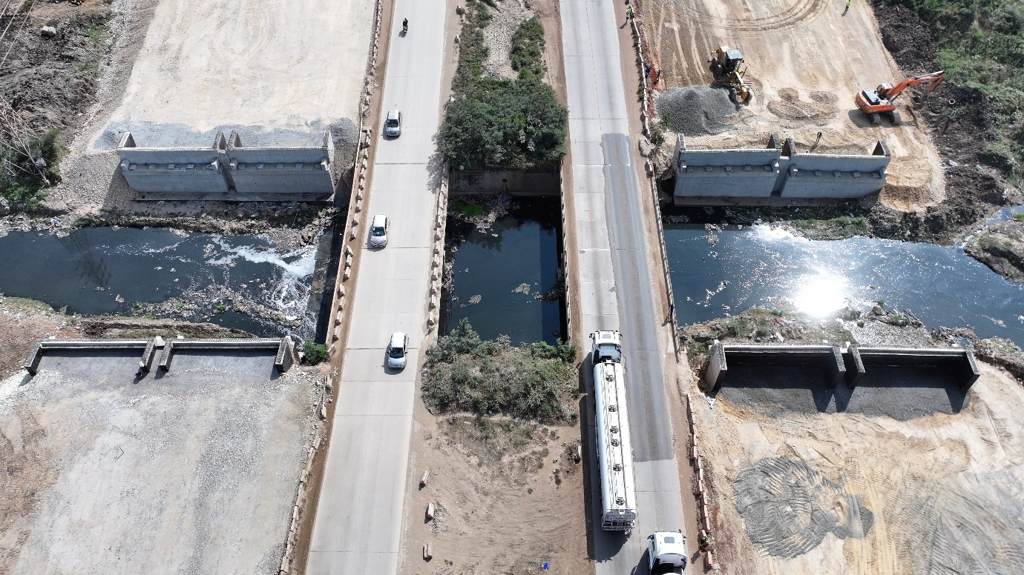
Figure 6 Bridge---Km 16+556.2LHS & RHS (1)

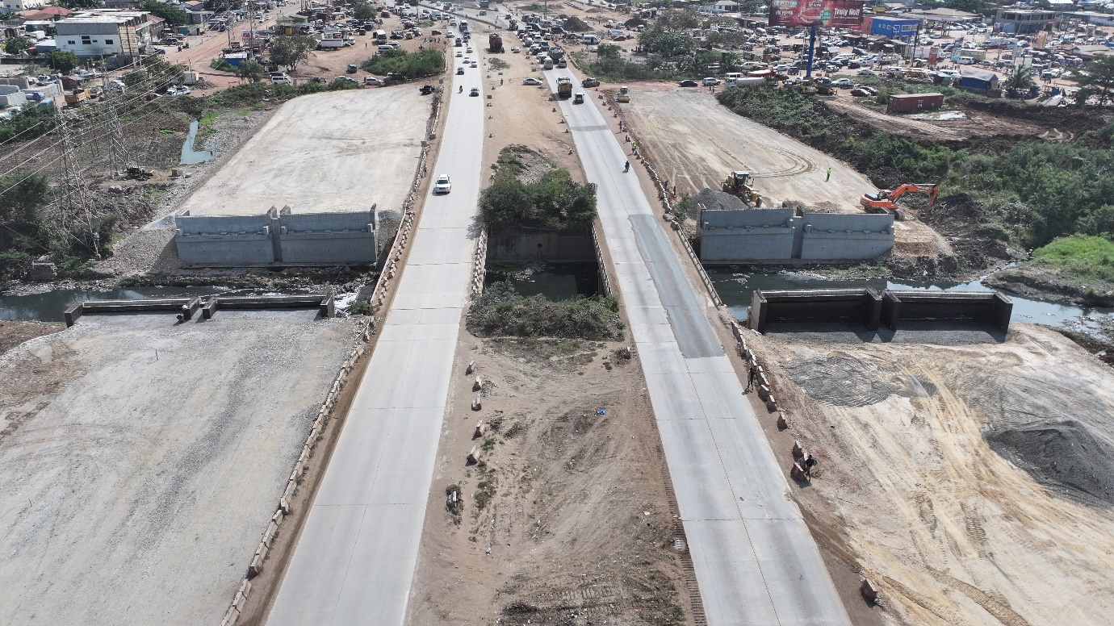
Figure 7 Bridge---Km 16+556.2LHS & RHS (2)

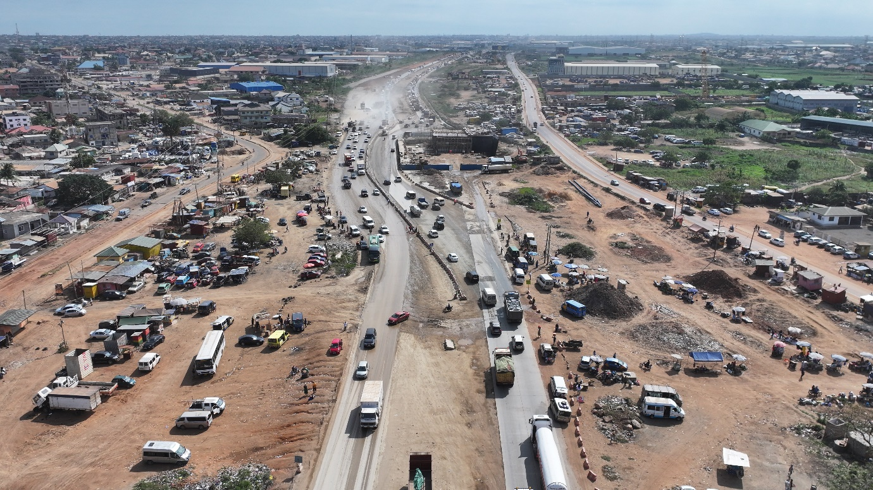
Figure 8 C18

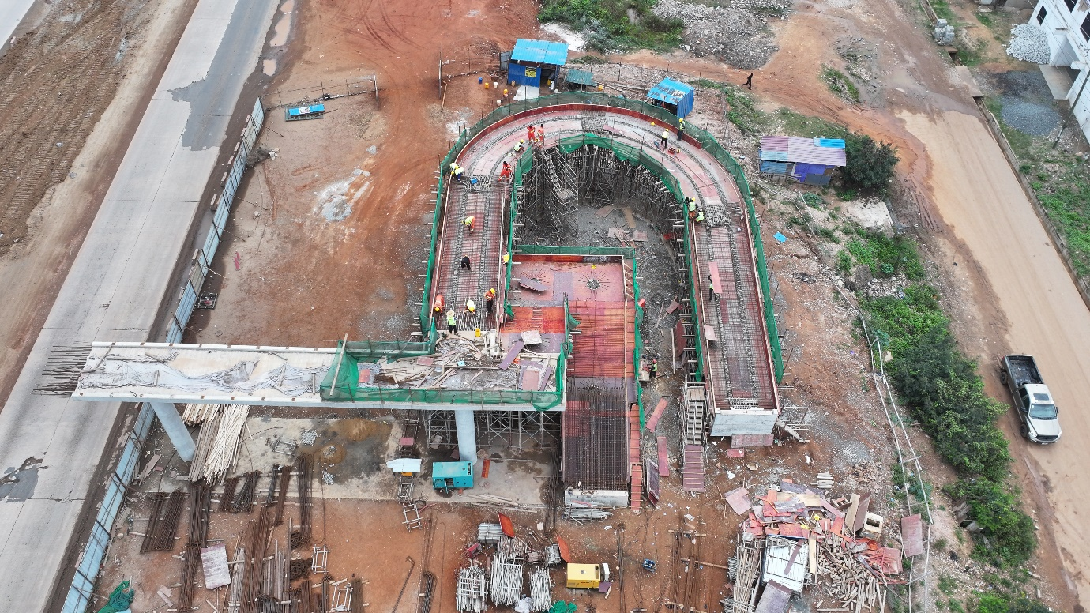
Figure 9 Footbridge 5#---Km 8+050 LHS (1)

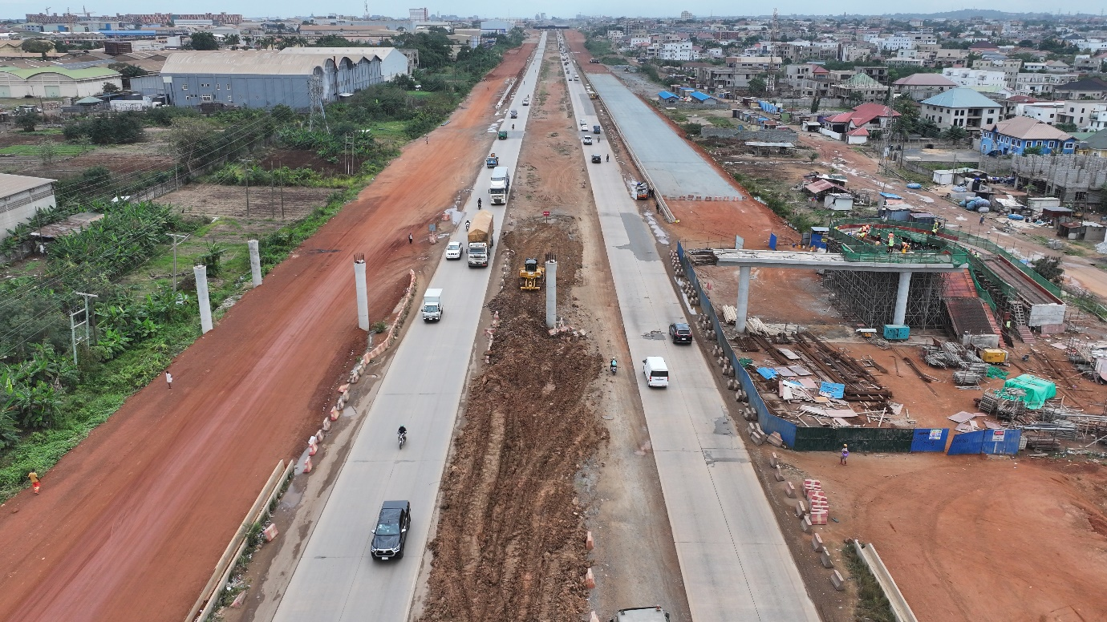
Figure 10 Footbridge 5#---Km 8+050 LHS (2)

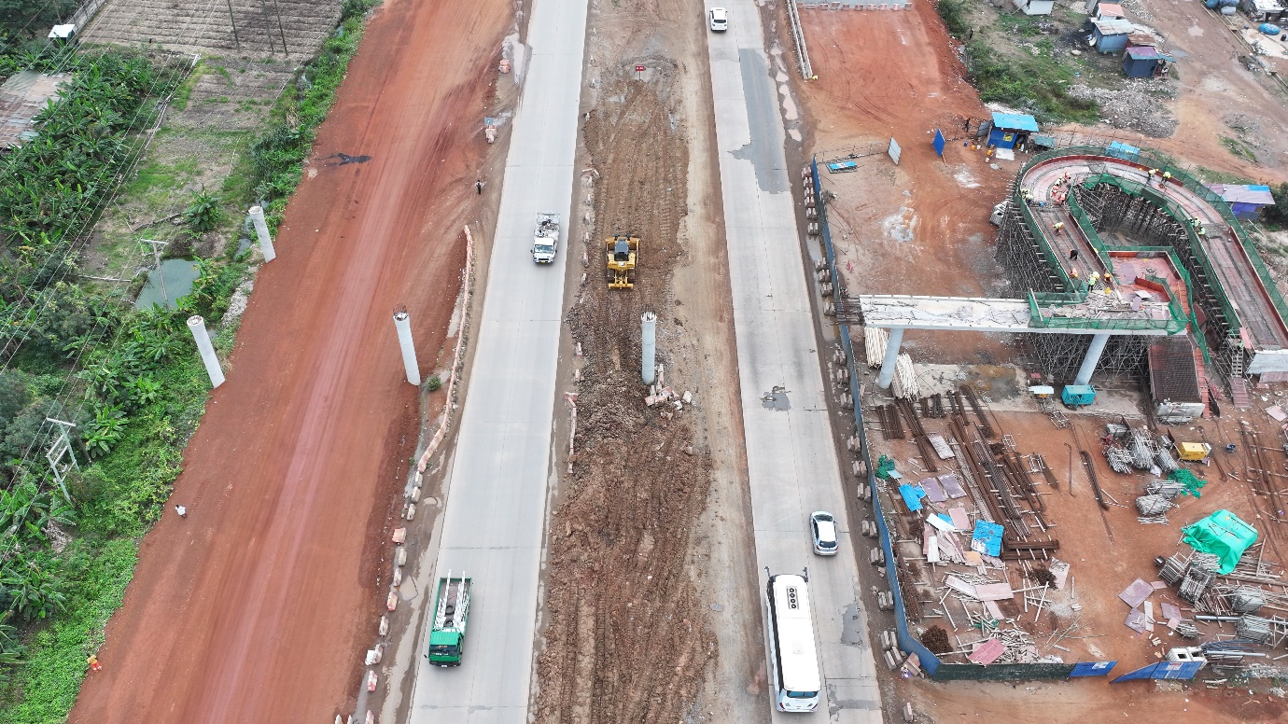
Figure 11 Footbridge 5#---Km 8+050 LHS (3)

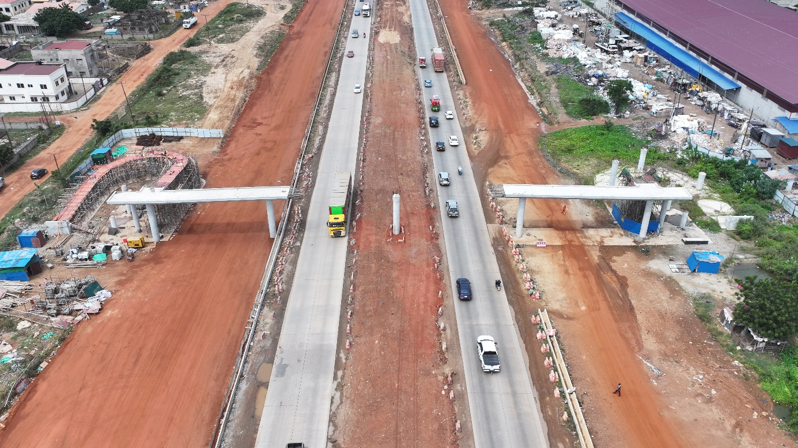
Figure 12 Footbridge---Km 9+920 LHS & RHS

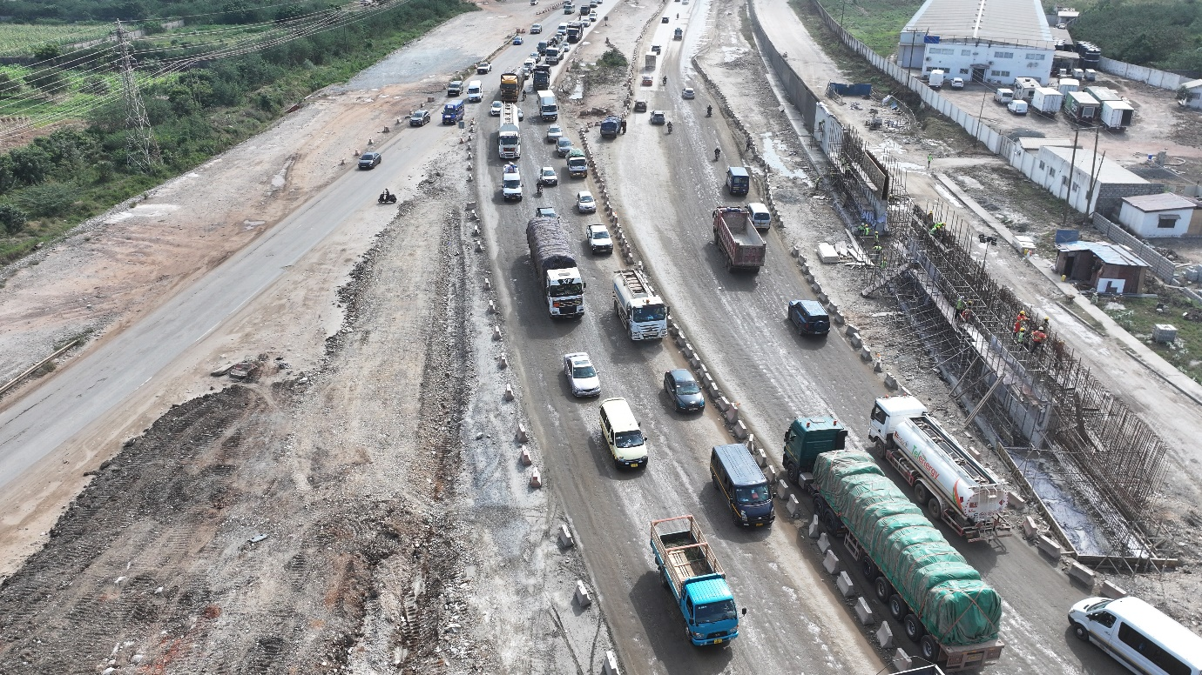
Figure 13 Retaining---Km 12+120 LHS (1)

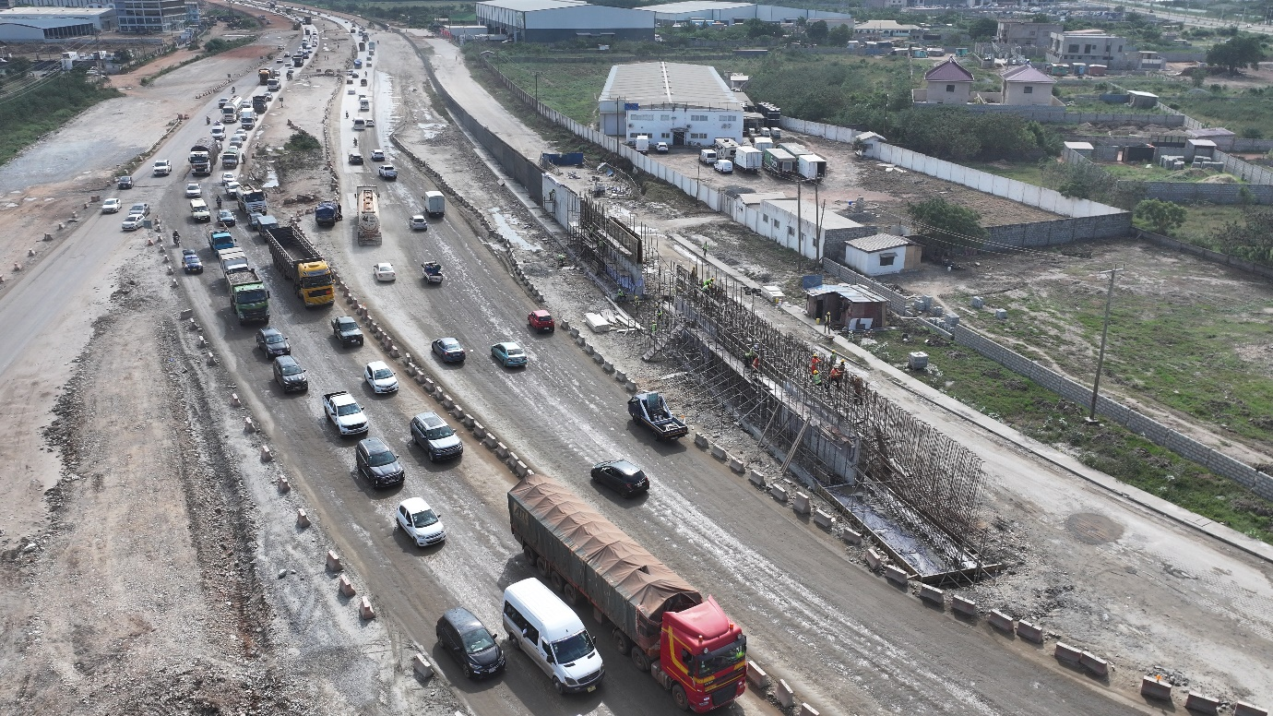
Figure 14 Retaining---Km 12+120 LHS (2)

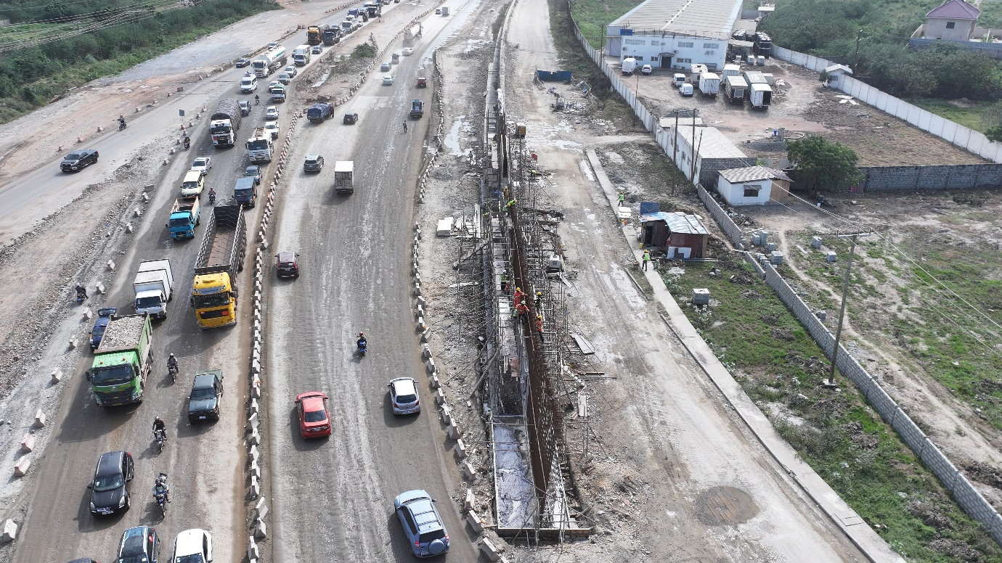
Figure 15 Retaining---Km 12+120 LHS (3)

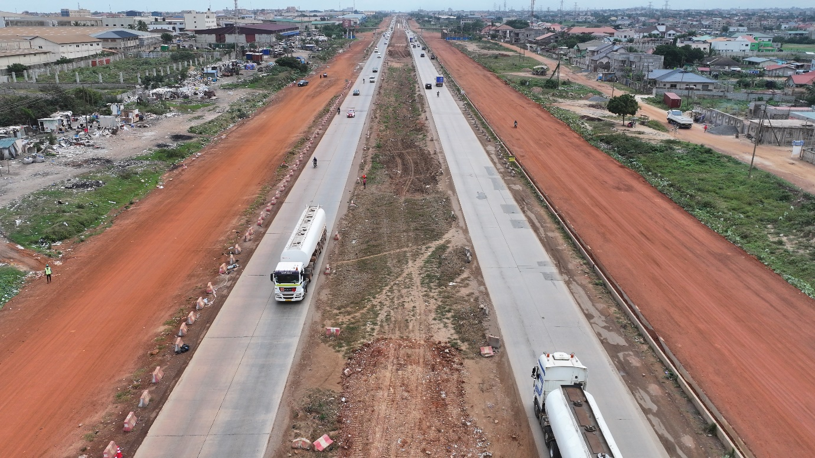
Figure 16 Roadbed---Km 9+000-Km 10+000 LHS & RHS

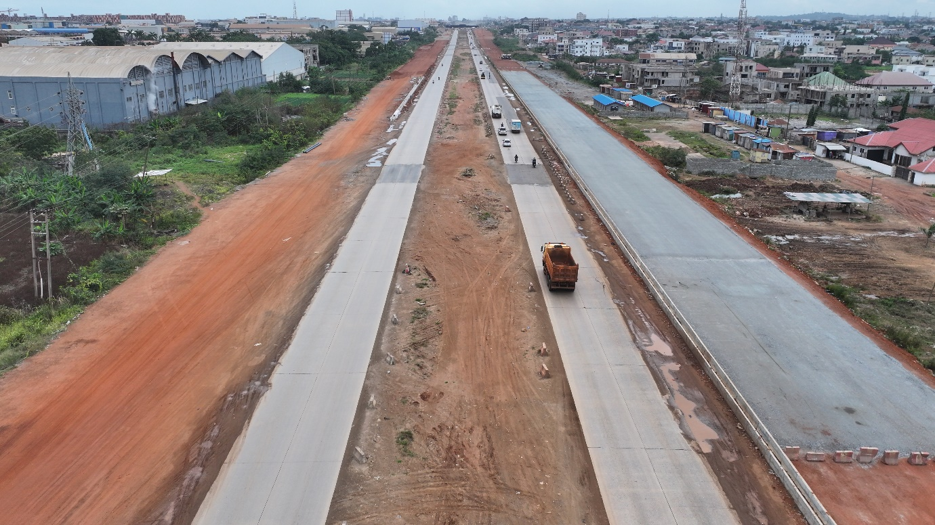
Figure 17 Subbase---Km 7+600-Km 7+980 LHS

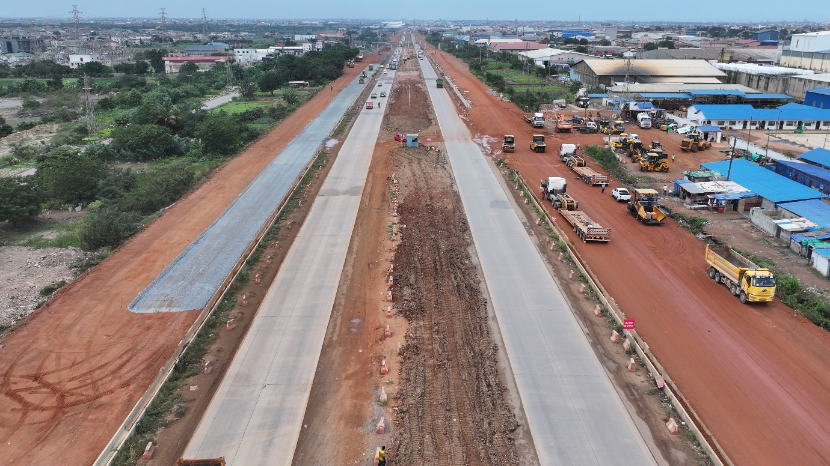
Figure 18 Subbase---Km 8+140-Km 8+340 LHS

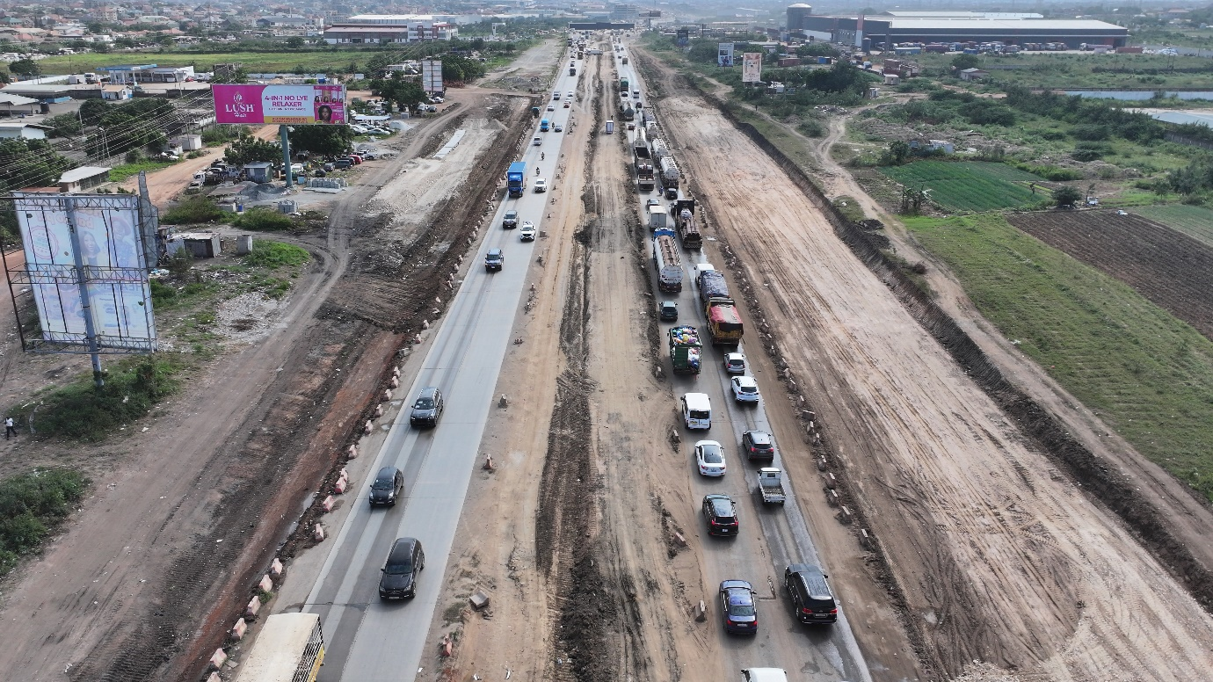
Figure 19 Subgrade---Km 13+300-Km 13+650 LHS & RHS

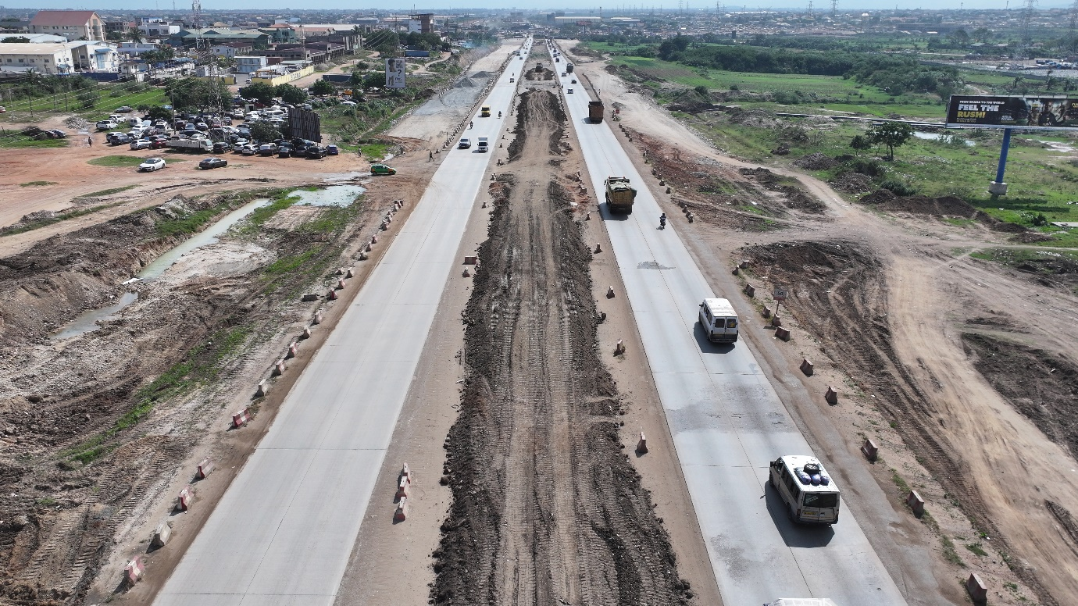
Figure 20 Subgrade---Km 17+200-Km 17+500 LHS & RHS

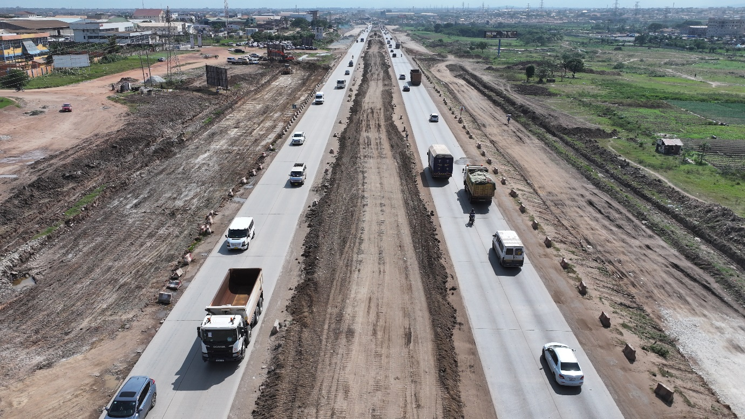
Figure 21 Subgrade---Km 17+500-Km 17+800 LHS & RHS

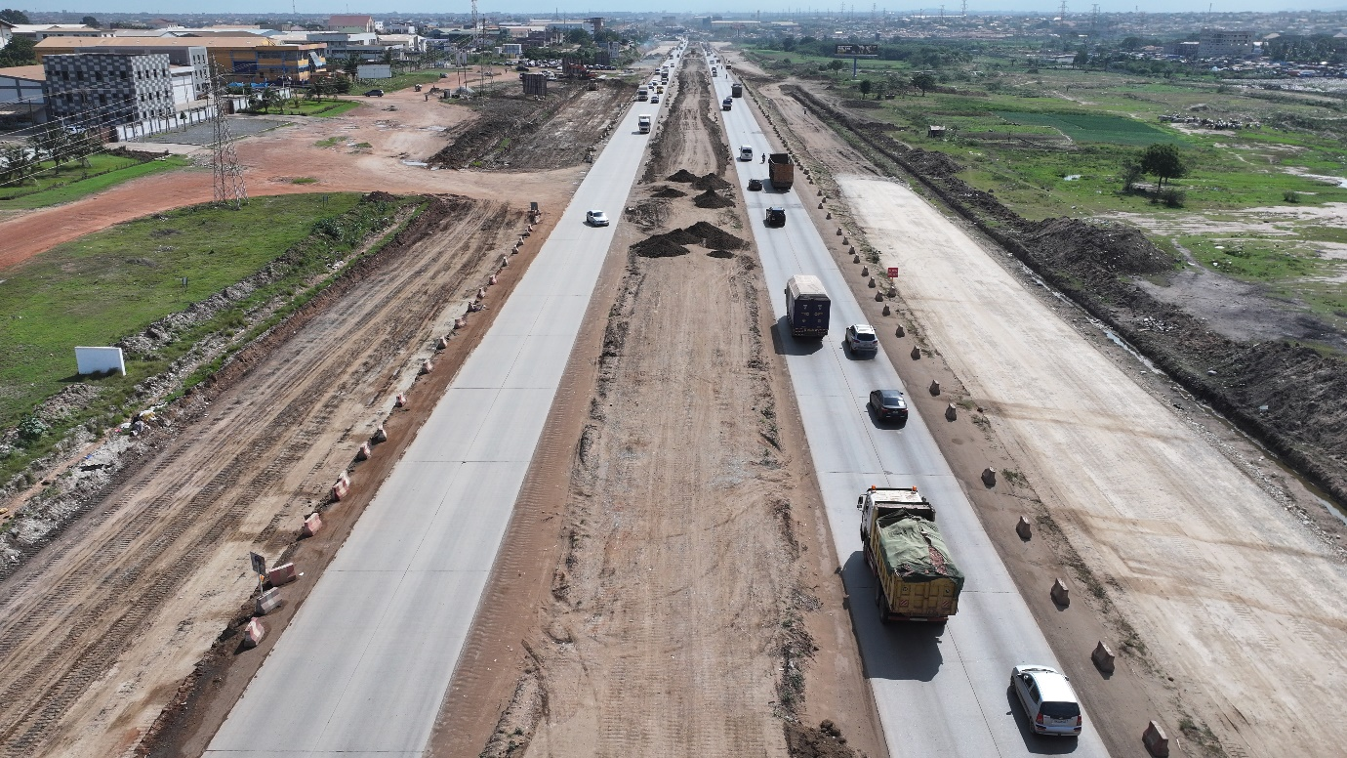
Figure 22 Subgrade---Km 17+500-Km 17+900 LHS & RHS

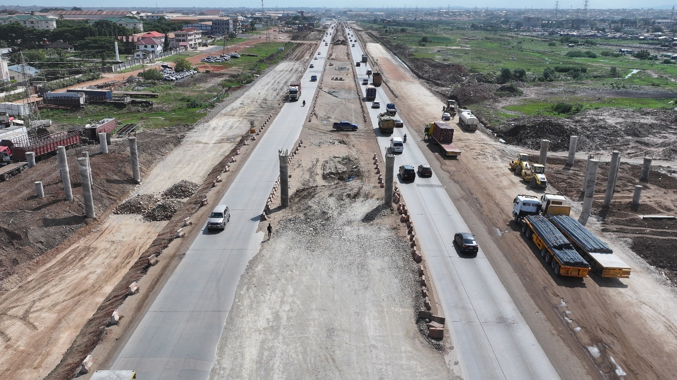
Figure 23 Subgrade---Km 18+000-Km 18+300 LHS & RHS

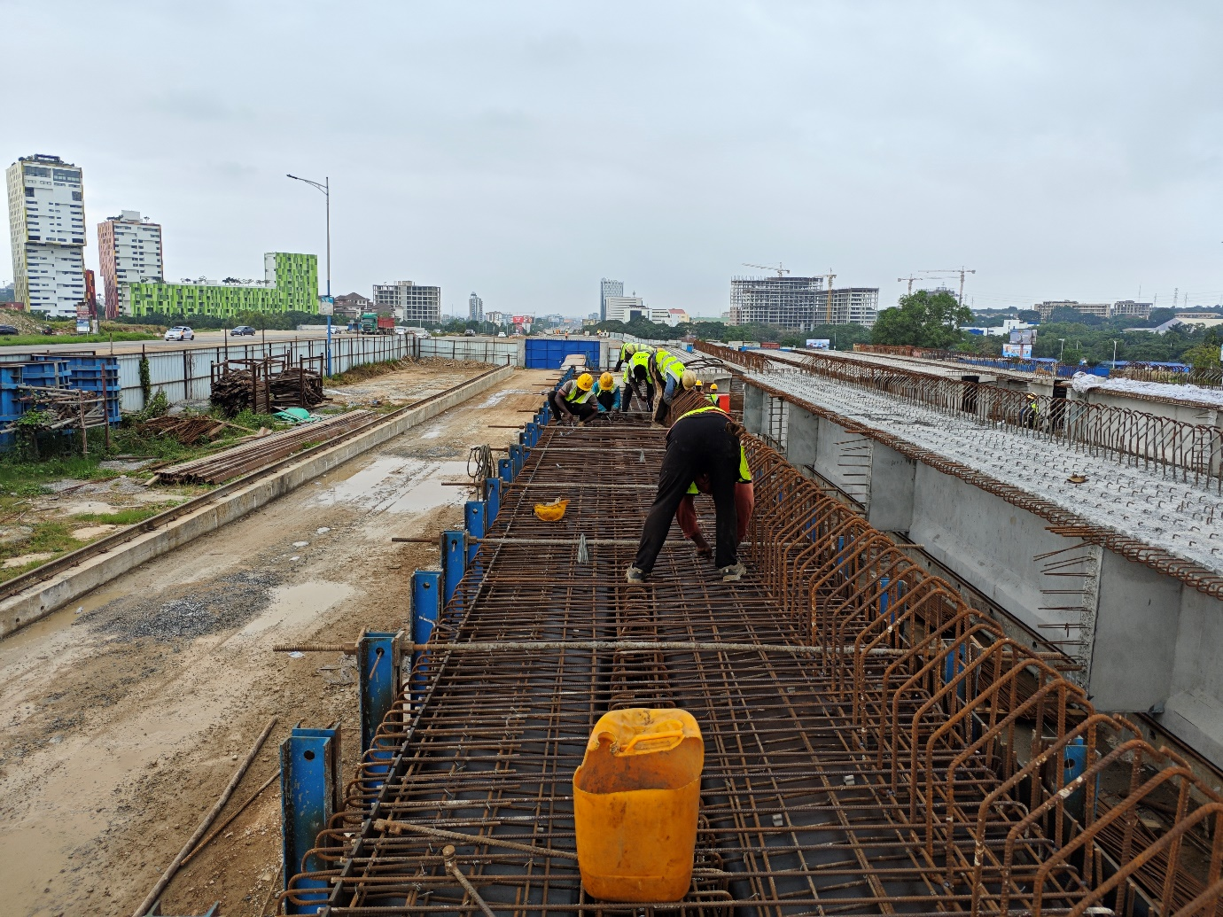
Figure 24 T beam

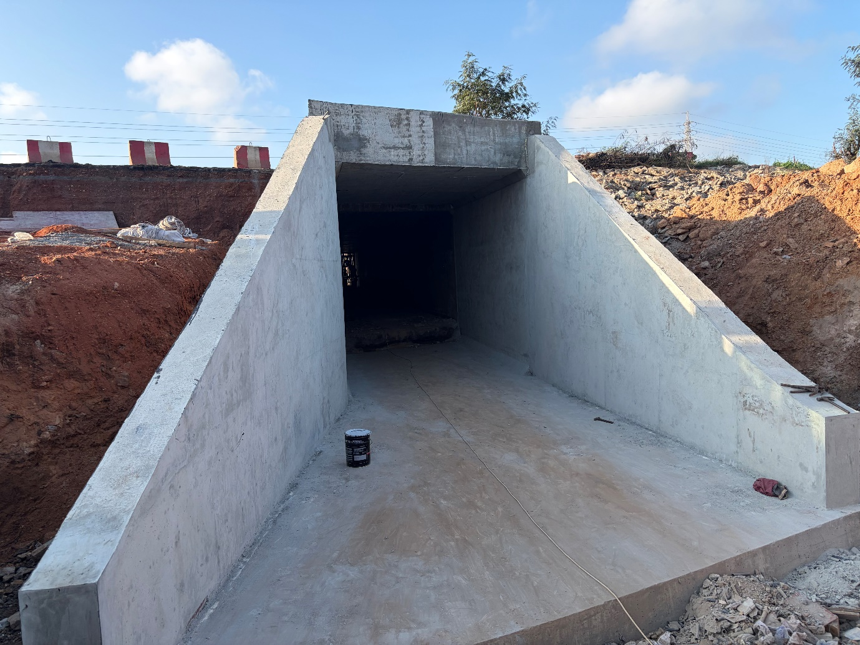
Figure 25 Underpass---Km 2+701

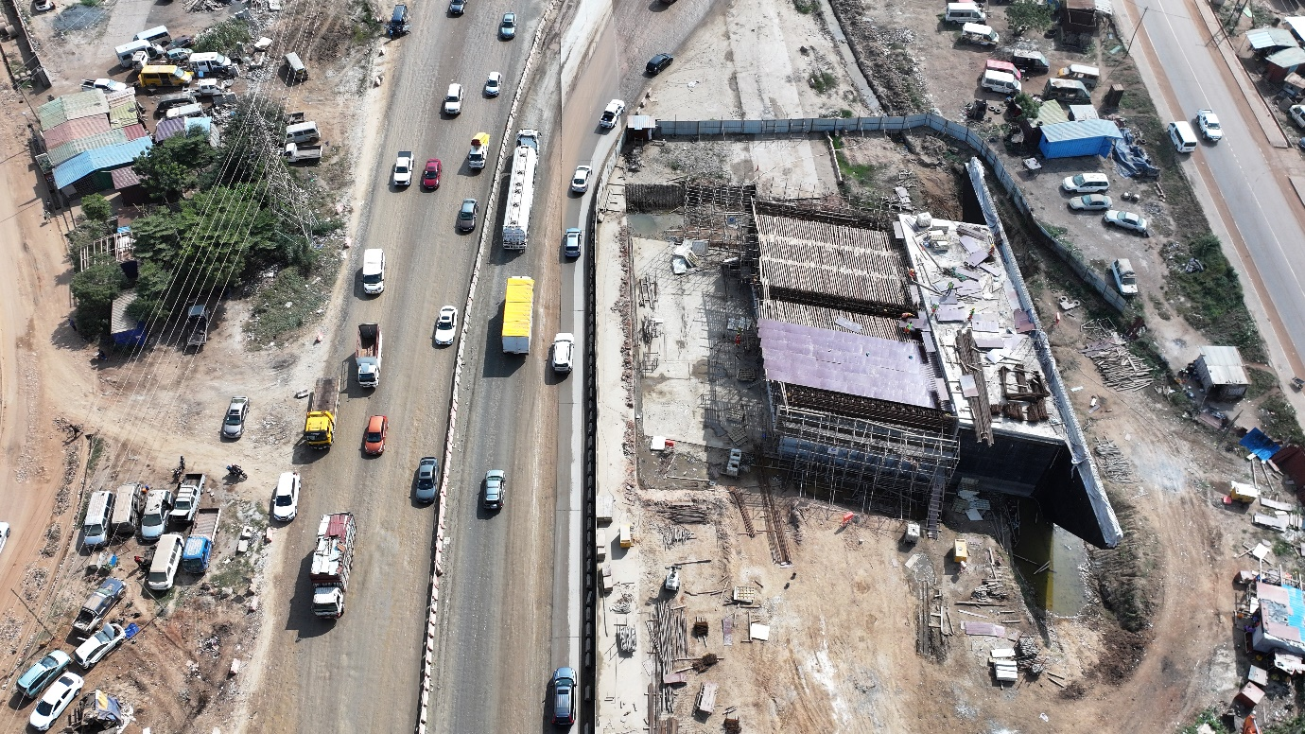
Figure 26 Underpass---Km 16+105.039 LHS & RHS (1)

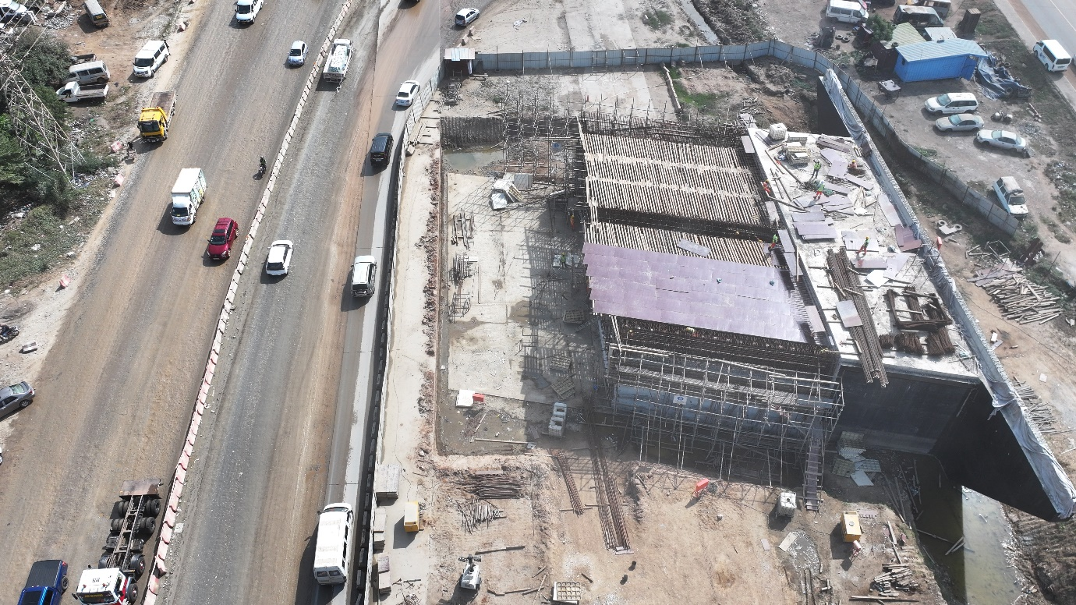
Figure 27 Underpass---Km 16+105.039 LHS & RHS (2)

